ONLINE MAGAZINES
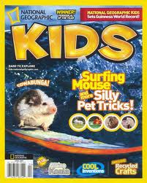
National Geographic Kids http://kids.nationalgeographic.com.au/kids/
Articles, Games, Videos, Craft, Puzzles, Homework Help, News, Countries, Photos

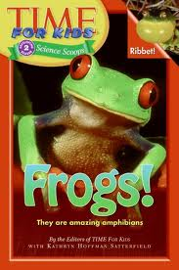
Time For Kids www.timeforkids.com
Kid Reporters, Around the World, News, Entertainment, Science, Homework Helper, Photos and Videos, Mini-Sites (eg Black History Month), Competitions.
Also available for iPad.

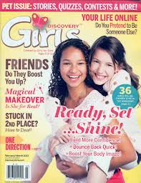
S Discover Girls http://discoverygirls.com
A magazine for tween girls with advice, fun stuff, discussions and reader blogs. Over half the content is from readers. Deals with topics that girls care about such as friendships, school, family.
In this month’s issue:
- How to be a people magnet?
- Terrific tips for taking tests
- What to do when boys harass you

