2017 Prospective Students

Title
Address
SUBURB NSW

In response to our BYOD Survey at the IT Information Night, there was a resounding interest in purchasing Bring Your Own Devices (BYOD) for the students in the 2016 Information Technology Selective Classes. Some students already have devices they wish to use for school and home, and those from Tuggerah will be able to use the Netbook purchased in their Year 5 School Information Technology program. For those parents / carers unable to provide a device for their child in 2016, please contact Ms Elizabeth Ebrill Head Teacher Information Technology at the start of the year to discuss alternative options.

In 2016 BYOD systems will be used, where appropriate, in a number of subject areas for research, collaboration and cloud based programs. It should be noted however, that it is important for students to continue to use hand written based work with IT specialist classes being taught in dedicated computer classrooms using specialist software not available to the general public.

The NSW Department of Education has collaborated with Google and Microsoft to allocate to each student and teacher unlimited access to their cloud based storage. Students are also permitted to download one free version of Microsoft Office.

For those that are interested in purchasing a BYOD for 2016, there are many options from a large number of suppliers. For example, Martin Harris from The Computer Guy from Charmhaven has proposed student purchases of either a brand new laptop computer or one of their refurbished models. He would be happy to discuss options and payments with you. Other local suppliers with BYOD packages could also be used such as Office Works at Tuggerah (Dean Collis).

Please find attached the BYOD Information Sheet. Further information regarding BYOD User Charter and Acceptable Usage Policy will be addressed with students week 1 Term 1 2016.

For any further queries, please contact Ms Elizabeth Ebrill at the school on 4353 1088. We are looking forward to working with all students and their parents / carers in 2016. Enjoy your Christmas and see you early in the New Year.
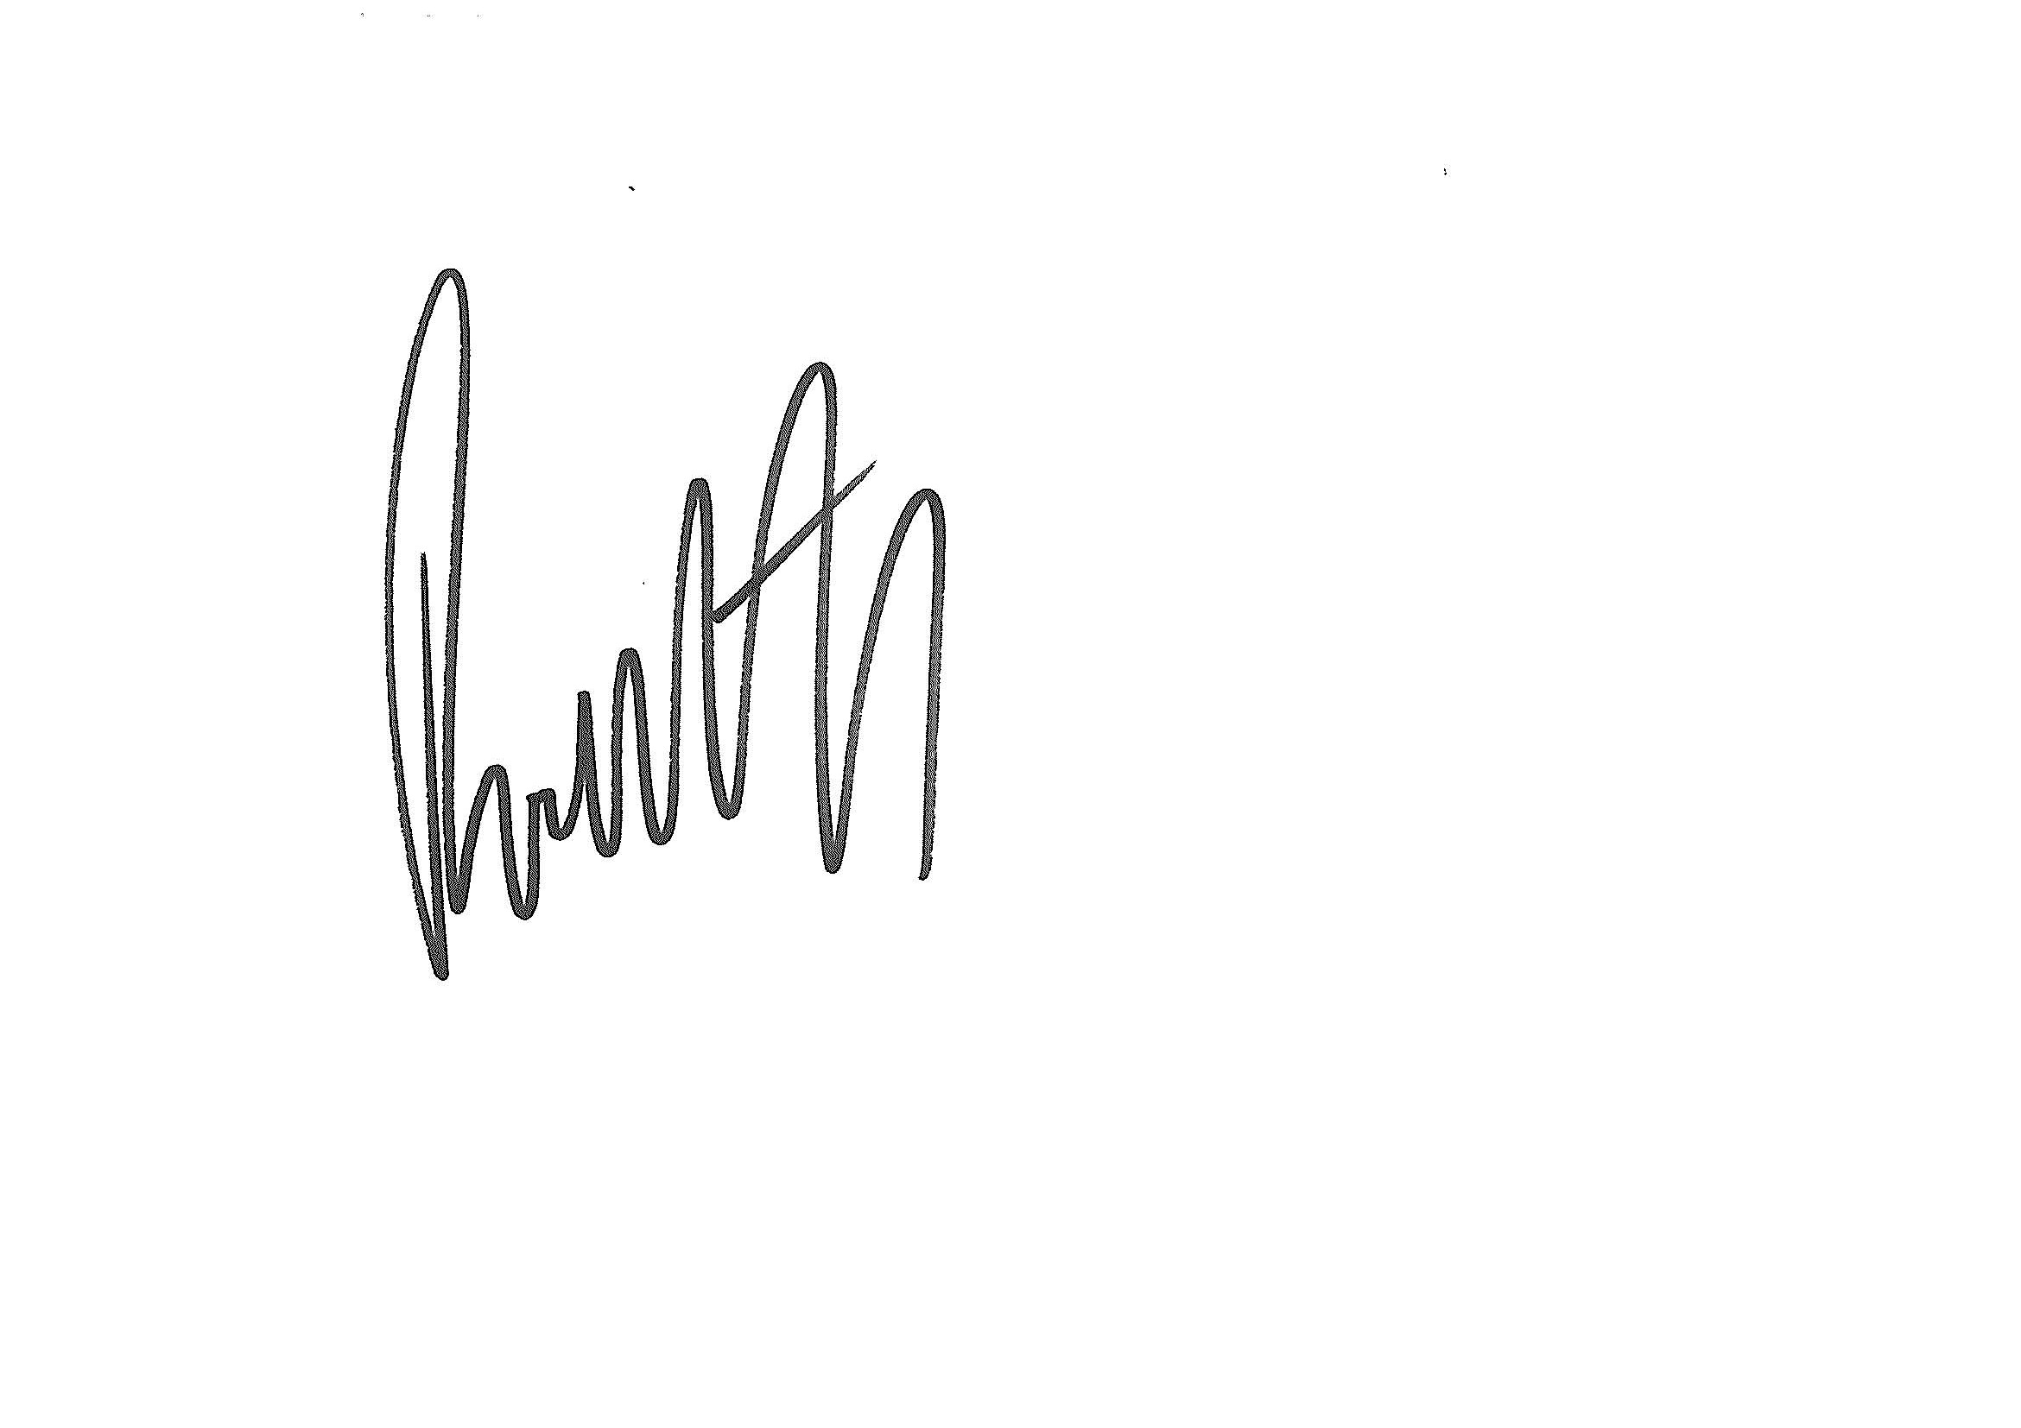
Kind regards,

Elizabeth Ebrill Rodney Hill
Head Teacher Information Technology Principal
Wyong High School Wyong High School

Wyong High School BYOD Information Sheet
From 2016 Wyong High School will be implementing a 'Bring Your Own Device' (BYOD) program. The BYOD Program will require all students in the Year 7 Information Selective classes to bring their own computing device to school each day.
If students are unable to provide their own device please contact Ms Elizabeth Ebrill Head Teacher Information Technology so other arrangements can be arranged.
Students and parents are responsible for ensuring the device brought to school meets all the requirements of the Device Specifications. A device which does not meet the specifications will not be permitted access to school networks and services.
Device specifications (see specifications page for more detail)
- Capable of connecting to the DEC wireless network - 5GHz
- Screen size minimum of iPad mini or similar size tablet (a smartphone is not acceptable)
- Battery power of at least 6 hours preferably longer
- Appropriate malware software installed
- Recommended (but not required) that students choose a laptop device that has a keypad and allows word processing applications or the free download of the DoE’s Microsoft Office software.
Students are solely responsible for the care and maintenance of their BYO devices. This includes but is not limited to:
- Managing battery life and regular charging of their device.
- Labelling and registering their device for identification purposes.
- Purchasing and using device protective casing.
- Ensuring the device is safe and secure during travel to and from school and throughout the school day.
- Maintaining up-to-date anti-virus software and operating system on their device.
- Taking insurance coverage of their own device to protect any accidental damage, theft or loss.
The personal device must be able to be brought to school every school day and be used solely by the student throughout the school day.
Prior to bringing a personal device for the first time, students and their parents must read and sign the BYOD User Charter and the Technology Acceptable Usage Policy which sets out the responsibilities and expectations for use of the personal device at Wyong High School.

BYOD Minimum Specifications
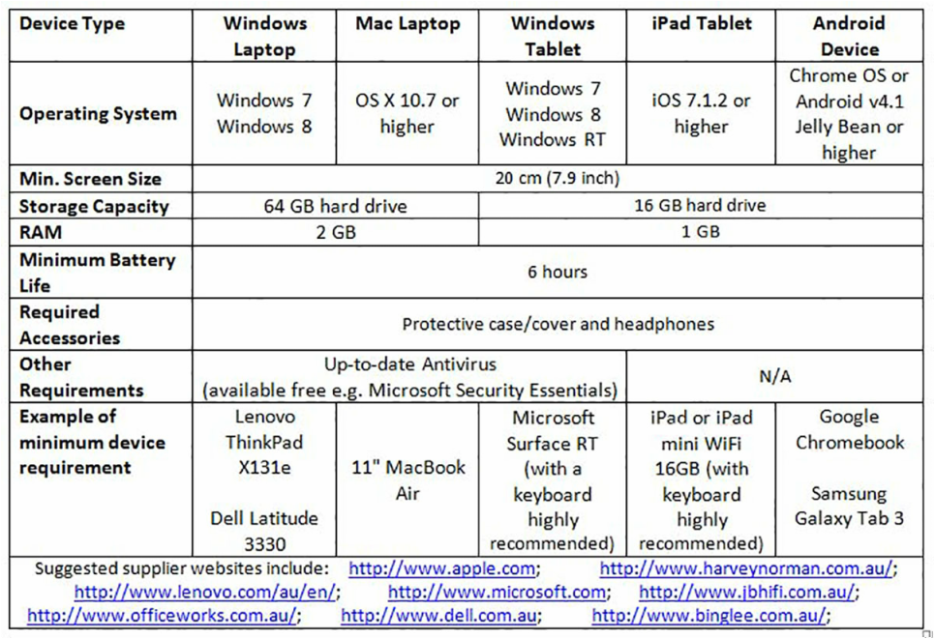
The BYOD Program asks students in the Year 7 IT Selective Information Technology classes to bring a computing device to school each day. This personal computing device needs to meet the minimum device specifications recommended by the school and listed below.
These device specifications identify the minimum system requirements/hardware specifications for student devices, and offer guidance on some suggested makes and models so that parents are fully informed about requirements.
While all devices in the table below meet the minimum system requirements/hardware specifications, the school strongly recommends that students choose a laptop device to ensure that their BYOD maximises their learning experiences, otherwise the addition of a separate keyboard with any tablet purchased is highly recommended.

PLEASE NOTE:
In order to ensure connectivity to the DEC wireless network it is recommended that any device is capable of connecting to a 5GHz network.

